TAKE HOME ASSIGNMENT-2
Roll no-12340740

1.procinfo.h
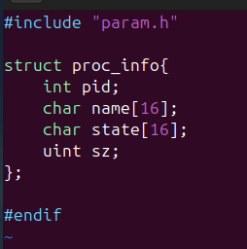
2.proc.c
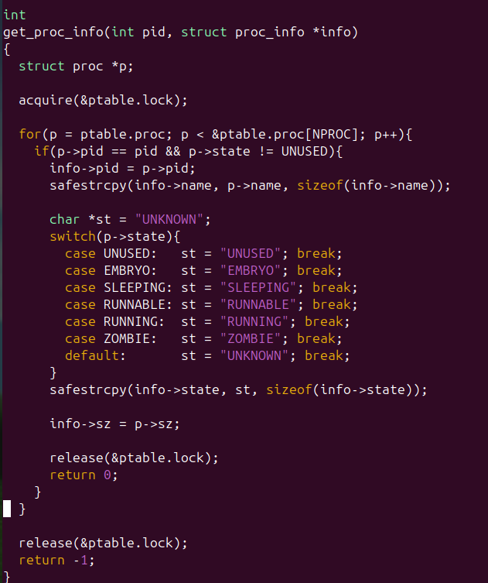
3.proc.h
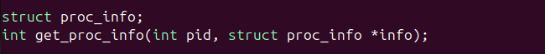
4.syscall.h

5.sysproc.c
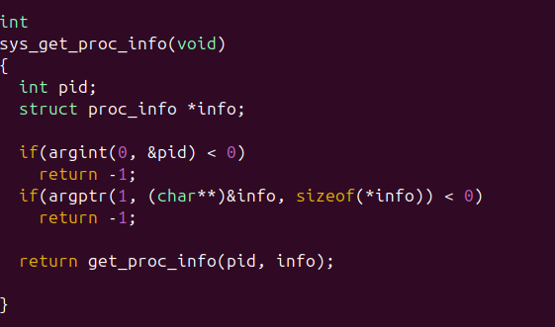
6.syscall.c
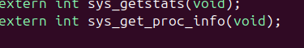
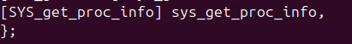
7.pinfo.c
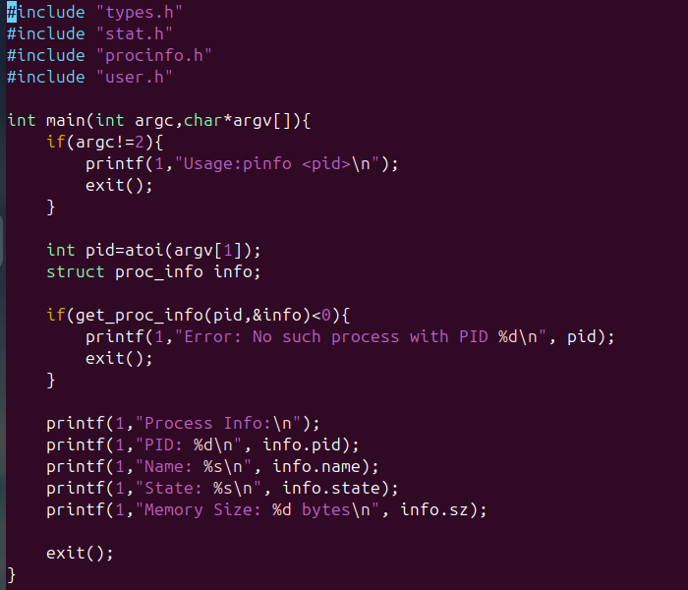
8.Makefile
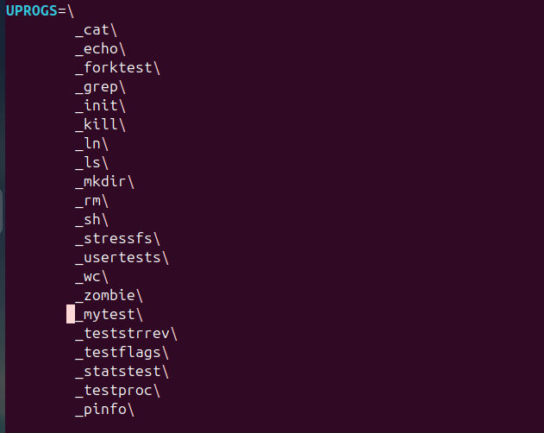
Output
